**Notes in ‘CLIMATE-INDUCED CYCLICAL PROPERTIES OF REGIONAL WINE PRODUCTION USING A TIME-FREQUENCY APPROACH IN DOURO AND MINHO WINE REGIONS Cunha-Richer’**

**Notes in Document**

**'Cunha_Richter_CTV.pdf':**

Highlight  *(Cunha_Richter_CTV.pdf, p.1)*

Highlight 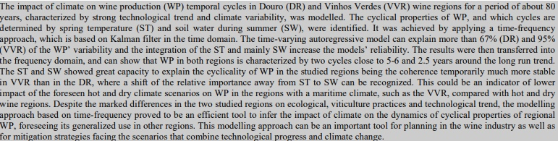 *(Cunha_Richter_CTV.pdf, p.1)*

Highlight : In Portugal grapevines are one of the most important perennial crops, growing in over 30 different denominations of origin, which support a reputed wine industry strongly linked to specific wine regions (Moriondo et al., 2013; IVV, 2018) *(Cunha_Richter_CTV.pdf, p.2)*

Highlight : recent adoption of common high-yielding grape varieties, uniform agronomic practices (e.g. irrigation) based on few grape varieties/clones with common timing of phenological dates (e.g. flowering) have caused grape-yields to become more strongly influenced by weather patterns (Martins et al., 1998), especially under the foreseen climate scenarios.  *(Cunha_Richter_CTV.pdf, p.2)*

Highlight : Unpredictable temporal variability of WP is a major threat for farmer and its associations, wine sellers, insurances, researchers, natural resources managers and policy makers among others (Quiroga and Iglesias 2009; Cunha et al., 2010). Therefore, there is a strong demand of adequate study of time series of regional WP in order to improve the efficiency of vineyard and winery operations as well as to support commercial strategies and sectorial planning measures (Cunha et al., 2016).  *(Cunha_Richter_CTV.pdf, p.2)*

Highlight : many of the impact assessments of the past, present and future climate conditions on wine yield have been carried out based on statistical models supported by long-term time series of WP and climate (e.g. Gouveia et al., 2011; Santos et al., 2011; Bock et al., 2013; Bonnefoy et al., 2013; Cunha and Richter, 2016; Teslić et al., 2019). However, there is still very little evidence how sensitive is the temporal variability of WP to the scenarios that combine technological progress and actual or future climate variability. *(Cunha_Richter_CTV.pdf, p.2)*

Highlight : This is largely due to the perennial nature of grapevine wherein cluster structures present in one year begin their development in the spring/summer of the previous year (Vasconcelos et al., 2009). *(Cunha_Richter_CTV.pdf, p.2)*

Highlight : long-term analysis of WP would have a key importance, at the light of the recent global and regional climate change scenarios (Jones, 2012; Santos et al., 2013), in order to plan future mitigation actions for viticulture and wine industry (Hannah et al., 2013; Mosedale et al., 2016).  *(Cunha_Richter_CTV.pdf, p.2)*

Highlight : Therefore, current-year production being physiologically dependent on conditions (ecological and agronomic) of the previous year and short-term carryover effects of carbon and water deficits could be expected (Guilpart et al., 2014; Maxwell et al., 2016). *(Cunha_Richter_CTV.pdf, p.2)*

Highlight : In Portugal, as in many other worldwide wine regions, despite unremitting improvements in vineyard technology, wine-yield remains highly dependent on the short and long-term climate, which causes important variations in WP with several adverse effects  *(Cunha_Richter_CTV.pdf, p.2)*

Highlight : These carryover effects (short-term) coupled with long-term (technological and climate) effects on WP make difficult the development of WP dynamics models and could explain the scarcity of well stabilized and generalized models to support wine industry. *(Cunha_Richter_CTV.pdf, p.2)*

Highlight : in the drier regions of the Mediterranean basin, where the foreseen climate scenarios pointed for substantial drying with precipitation reductions of more than 25% and warming by 3-5 ºC by 2080 *(Cunha_Richter_CTV.pdf, p.2)*

Highlight : The WP time series are not stationary and include transitory components, consisting of a variety of frequency regimes that may be localized in space or have short-lived transient  *(Cunha_Richter_CTV.pdf, p.2)*

Highlight : components and features at different scales (Cunha and Richter, 2016). Stationarity means not only that a series has a constant mean and constant and finite variance, but also that the autocovariances are not functions of time (Ye et al., 2015). *(Cunha_Richter_CTV.pdf, p.3)*

Highlight : Predictable behaviour of such WP system like trends and cyclicality proprieties, is therefore of great interest but a challenging research line in order to develop dynamic models.  *(Cunha_Richter_CTV.pdf, p.3)*

Highlight 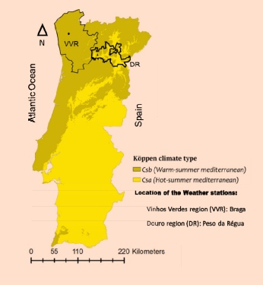 *(Cunha_Richter_CTV.pdf, p.3)*

Highlight : studies based on autoregressive model (Cunha and Richter, 2012), climate (Esteves and Orgaz, 2001; Fraga et al., 2014) or measures of radial grape growth rings (Maxwell et al., 2016), point towards identifiable induced-climate cyclicality of WP *(Cunha_Richter_CTV.pdf, p.3)*

Highlight : This paper provides a long-term analysis of induced- climate cyclicality of WP in Douro (1933-2013) and Vinhos Verdes (1937-2016) wine regions. Specifically, about eighty years of WP and climate data from two wine regions in Portugal very different in terms of ecological conditions, vineyards techniques and technological trend, are examined to see how there WP patterns are affected by climate. Firstly, the frequency location of the variance in the WP was performed in order to find the dominating cycles. *(Cunha_Richter_CTV.pdf, p.3)*

Highlight : The second step, identifies the importance of climate variability for the cyclical properties of WP, and analyse the predictability of these events. A time- frequency approach is applied, which not only gives the cyclical properties of WP, but also how they changed over time, may be due to climate variability. *(Cunha_Richter_CTV.pdf, p.3)*

Highlight : The VVR is located in the northwest part of Portugal in an area traditionally known as Entre-Douro-e- Minho, the most Atlantic wine region of Portugal. Grapevines grown in VVR have unique characteristics, namely, the form of guiding systems with wide vegetative expansion and growth high above the ground.  *(Cunha_Richter_CTV.pdf, p.3)*

Highlight : The Kalman Filter is used to estimate the parameters in the time domain which are then transferred into the frequency domain *(Cunha_Richter_CTV.pdf, p.3)*

Highlight : The DR is located in northeast part of the country, where vineyards are mainly built over terraces and slopes with soils mostly derived from shale. Also, mostly in the eastern part of this region, the vineyards are located in some of the most arid, non-irrigated, regions of Europe.  *(Cunha_Richter_CTV.pdf, p.3)*

Highlight : This paper analysis the two main wine regions of Portugal: ‘Vinhos Verdes’ appellation of Origin (VVR) and the Douro Demarcated Region (DR) (Figure 1). These regions represent at about 32% of Portugal’ vineyard area and 37% of the wine production (IVV, 2018). *(Cunha_Richter_CTV.pdf, p.3)*

Highlight : This region, famous for its Port wine, is responsible for about one fourth (23%) of all wine produced in Portugal (IVDP, 2018), *(Cunha_Richter_CTV.pdf, p.3)*

Highlight : The average temperature for the year in VVR ranges between 12.5 and 15.8 °C, and in DR is 11.8 and 16.5 ºC. The warmest month, on average, is August in both regions with an average temperature of 20 ºC (VVR) and 24.4 ºC (DR), and the coolest month on average is January, with an average temperature of 8.8 °C (VVR) and 8.0 ºC. The average amount of annual precipitation varies from 1200 to 2000 mm in VVR and 400 to 800 mm in DR, most of which occur in autumn and winter *(Cunha_Richter_CTV.pdf, p.4)*

Highlight : According to Köppen’s classification, VVR belongs to the climate type Csb, while the climate in DR is Csa type (Figure 1). The Csb is characterized by mild climate with dry and hot summers with average temperatures below 22 °C, and has four months of the year when temperatures do not fall below 10 °C. The Csa is mild climate with dry and hot summers, with average temperatures in the hottest month exceeding 22 °C.  *(Cunha_Richter_CTV.pdf, p.4)*

Highlight : The ST includes a period of high intensity of growth and the reproductive phase between flowering and fruit-set which are physiological dependent of temperature, while the SW period includes the vegetative phase between veraison and harvest, characterized by strong potential hydric stress.  *(Cunha_Richter_CTV.pdf, p.4)*

Highlight : During the period April – October, the mean temperature is about 17.1 ºC in VVR and 19.5 °C in DR, and according to the climate maturity grouping (Jones, 2007), the growing season can be defined as ‘Intermediate’ and ‘Hot’, respectively.  *(Cunha_Richter_CTV.pdf, p.4)*

Highlight : Daily weather data covering all the period analysed were subject to quality control to examine outliers, adjust missing data values, and check the temporal homogeneity of the data, using the procedures developed by Peterson et al. (1998) and applied by Jones (2012) in DR. The R_Studio application RHtestsV4 was used for the assessment of the quality of the meteorological data: http://etccdi.pacificclimate.org/software.shtml *(Cunha_Richter_CTV.pdf, p.4)*

Highlight : In the VVR, with a wetter post-flowering period, diseases incidence generated production losses are frequent. In the DR, being hotter and drier after flowering, the problems associated with grape diseases are less frequent (Cunha et al., 2003). *(Cunha_Richter_CTV.pdf, p.4)*

Highlight : The annual wine production data used in this work was provided by: ‘Instituto dos Vinhos do Douro e Porto’ (IVDP, 2018) for DR (1933-2013) and ‘Comissão de Viticultura da Região dos Vinhos Verdes’ (CVRVV, 2018) for VVR (1937-2016) *(Cunha_Richter_CTV.pdf, p.4)*

Highlight : Time-frequency analysis of the wine production  *(Cunha_Richter_CTV.pdf, p.5)*

Highlight : the time series of wine production in the DR (1933-2013) and VVR (1937-2016). The series are more likely to present different degrees of temporal stationarity or non-stationary behaviour. Also, for most of the sample this time series show a lot of variation, *(Cunha_Richter_CTV.pdf, p.6)*

Highlight : There is an evident up-ward (DR) and down-ward (VVR) trend in wine production. The expected long- term trend in the times series of WP with more than 79 years is mainly a reflection of the changes in production area, vineyard practices and viticulture decisions such as changes in grape varieties. As the  *(Cunha_Richter_CTV.pdf, p.6)*

Highlight : In both equations, only the 5th lag is significant at the 5% significance level. However, in between the lag structure is different as the 4th and 6th lag is included but not the 1st. The developed time-varying autoregressive model explains 67% and 95% of the WP variability, respectively, in DR (Table I) and VVR (Table 2).  *(Cunha_Richter_CTV.pdf, p.7)*

Highlight : The time-varying spectrum presented in Figure 3, which is based on the autoregressive model presented on Table I for DR, shows the dynamic characteristics of the WP. Over the entire frequency band, there are three distinctive peaks at frequencies 0.1, 1.1 and 2.5.  *(Cunha_Richter_CTV.pdf, p.7)*

Highlight : Hence, currently WP is characterised by a long run trend (frequency 0.1) and two shorter cycles of 5.7 years (frequency 1.1) and 2.5 years (frequency 2.5). This means that the time span from one peak in WP to another is close to 6 and 2.5 years, respectively.  *(Cunha_Richter_CTV.pdf, p.8)*

Highlight : Previously, Cunha and Richter (2012) developed a time-varying parameter model for the DR vs WP based on the ST for the period 1966 to 2007. It is worth noting that although the regression results are very similar to those of Cunha and Richter (2012) for the DR’ WP for the period 1966 to 2007, the availability of new data (1933 to 2013) meant that the second important cycle is now 5.7 years instead of 4.7 years. T *(Cunha_Richter_CTV.pdf, p.8)*

Highlight : That is, the new data shifted the second cycle by one year approaching it to the 4.7-year cycle found in the VVR for the period (1937-2016).  *(Cunha_Richter_CTV.pdf, p.8)*

Highlight : (ST3) have significant impact on the WP. In opposition to the current ST, an increase in the previous STs has a negative impact on WP. Also, the first and the 5th lag of WP are both significant at the 5% significance level.  *(Cunha_Richter_CTV.pdf, p.9)*

Highlight : As can be seen from Figure 4 the VVR power spectrum is towards the end of the sample characterised by three dominant frequencies: the long run trend, the frequency of 1.3 and 2.6, which corresponds to the 4.8 and 2.4 year cycles,  *(Cunha_Richter_CTV.pdf, p.9)*

Highlight : these two WP cycles around 5-6 years and 2.5 years detected in both regions are also consistent with other previous studies for VVR (Fraga et al., 2014) and Dão (Esteves and Orgaz, 2001) Portuguese wine regions.  *(Cunha_Richter_CTV.pdf, p.9)*

Highlight : In summary, the WP spectrum in both regions are characterised by a long run trend coupled with two shorter cycles. The great influence of the long run trend in DR and VVR confirms the results presented in Figure 2.  *(Cunha_Richter_CTV.pdf, p.9)*

Highlight : The regression of WP with ST for VVR *(Cunha_Richter_CTV.pdf, p.9)*

Highlight : In terms of shorter cycles, it is remarkable that both regions exhibit only two more dominant cycles. The medium cycle is one year apart from each other whilst the short-term cycle is close to one year apart from each other *(Cunha_Richter_CTV.pdf, p.9)*

Comment: ST impact and lag ST  
Lag WP also important  *(Cunha_Richter_CTV.pdf, p.9)*

Highlight : As for the DR, the relationship between WP and ST in VVR is also time dynamic. At the end of the sample, WP depends on the first and second lag of WP but also on the ST in the current year as well as the ST of two (ST2) and six (ST6) previous years (all at 5% significance level).  *(Cunha_Richter_CTV.pdf, p.9)*

Highlight : In comparison to the autoregressive model (Table I), the regression with ST presents similar values for Radj-square (0.65). However, this model with the ST is preferable to the autoregressive one for the lower AIC value (317 in comparison to 539), which of course does not mean that it is the “best” possible model, as the AIC does not reflects the absolute quality of a model. The WP in DR can be modelled using ST. At the end of the sample the current ST as well as the ST of previous two (ST2) and three years *(Cunha_Richter_CTV.pdf, p.9)*

Highlight : It can see from Figure 5 that WP in DR is determined by ST through three main cycles. Although other cycles matter as well, the most important ones are assessed: the longer cycle at a frequency of 1.3 (5.8  *(Cunha_Richter_CTV.pdf, p.9)*

Highlight : In both regions, the current-year impact of ST is positive, that is, an increase in current year ST will lead to a rise in WP of this year, while previous ST have a negative impact on WP. The biggest negative impact on WP has the ST of previous three years in DR and two years in VVR.  *(Cunha_Richter_CTV.pdf, p.10)*

Highlight : years), the medium term cycle at frequency 1.5 (4.2 years) and the short term cycle at frequency 2.9 (2.2 years), which has been happening since the 80s. Since 2003, the link for the long run cycle has decreased from over 60% to just over 50%. The medium cycle remained largely constant at 40%, whilst the short term cycle decreased from 50% to 40% as well. This means that medium cycles have the same impact on WP than short term fluctuation. *(Cunha_Richter_CTV.pdf, p.10)*

Highlight : The positive effect of current-year ST on WP is in line with the previous study for DR (Gouveia et al., 2011; Cunha and Richter, 2012; Santos et al., 2013; Cunha et al., 2016) and, VVR (Fraga et al., 2014), Spain (Lorenzo et al., 2013), Germany (Bock et al., 2013) and EUA (Lobell et al., 2007).  *(Cunha_Richter_CTV.pdf, p.10)*

Highlight : The positive impact of the ST on the WP could be related with more favourable conditions for physiological processes linked with grape yield that occur in Spring such as anthesis and fruit-set, which are favoured by warm and dry conditions (Cunha et al., 2003; May, 2004; Vasconcelos et al., 2009; Guilpart et al., 2014).  *(Cunha_Richter_CTV.pdf, p.10)*

Highlight : Moreover, high spring temperature leads to anticipation of the phenological stages with great impact on avoiding soil water stress and, consequently on wine production (e.g. Reis et al., 2018). Therefore, this shortening of the vegetative cycle could results in less vegetative vigour and less accumulation of carbon in the plant’s permanent structure (Mosedale et al., 2016). Thus, consecutive years of high ST may affect the production of the following years through the carryover effects of low carbon fixed and allocated to growth, *(Cunha_Richter_CTV.pdf, p.10)*

Highlight : In summary, in DR there is a stable but not constant link between the production and the ST. The temperature is still important for explaining about 60% the long term and short term behaviour of wine production, but its importance has decreased ( *(Cunha_Richter_CTV.pdf, p.10)*

Highlight : Figure 6 shows that the two pre-dominant cycles in VVR are at a frequency of 1.3 and 2.5, which correspond to 4.8 and 2.5 years cycle *(Cunha_Richter_CTV.pdf, p.10)*

Highlight : The longer cycle is just in between the 4.2 and 5.8 years cycles of the DR with the highest coherence. The shorter cycle is not far off the 2.2 years of the DR. *(Cunha_Richter_CTV.pdf, p.10)*

Highlight : DR. Hence, SW is clearly more important to WP than ST when it comes to predicting WP in DR. However, ST is also important for WP as pointed out above.  *(Cunha_Richter_CTV.pdf, p.11)*

Highlight : cycles. Whilst for the DR the 7 years cycle is most important, for the VVR it is the 1.5 years cycle. In both cases, the main cycles are very distinct  *(Cunha_Richter_CTV.pdf, p.11)*

Highlight : The effects of SW in WP depend on the time (Table I). The immediate effect on current-year WP of an increase in SW is negative, whilst the SW that is in the ground, that is from the previous two and three years, have a positive effect on WP.  *(Cunha_Richter_CTV.pdf, p.11)*

Highlight : WP is a dynamic process. It depends on the 3rd lag of the WP and the same year SW. As shown above, the SW has a negative impact on the current year WP. In contrast to DR, the impact of SW from the previous years does not have a significant effect on WP in the VVR. *(Cunha_Richter_CTV.pdf, p.11)*

Highlight : Figure 7 shows that the coherence between WP and SW in DR is quite stable and centred around a frequency of 0.9 or 7 years as well as a short one cycle of 2.4 years which has been happening since the 1990s. However, it is evident that SW can explain 7 year cycles by 60% in recent years (since the late 1990s). In previous years this link was in between 40%- 50%. So, there is evidence that the impact of SW on WP increased over time. *(Cunha_Richter_CTV.pdf, p.11)*

Highlight : time. With regards to the 2.4 years cycle, this is even more evident: before the late 90s, SW could only explain an average 12% of the 2.4 year cycle. This has increased to 30%. *(Cunha_Richter_CTV.pdf, p.11)*

Highlight : Wine production depends more on SW than on ST. The SW has a negative impact on the WP of the current year in both regions, while the SW in the previous two or three years has a significant positive impact on WP in DR  *(Cunha_Richter_CTV.pdf, p.11)*

Highlight : I). The negative effect of SW on the WP of the current year is in line with the findings of other authors for different regions (Jones and Davis, 2000; Bock et al., 2013; Lorenzo et al., 2013; Fraga et al., 2014). In DR and VVR, as in many other hot and predominantly non-irrigated regions, a high level of SW is associated with a high vegetative vigour of the plants, conditions prone to increase the risk of infection and severity of fungal diseases (e.g. botrytis, downy mildew) and, consequently, potential harvest damages (Valdés-Gómez et al., 2011).  *(Cunha_Richter_CTV.pdf, p.11)*

Highlight : Figure 8 shows the coherence between SW and WP for the VVR. For the entire sample there are three distinctive frequencies visible: the long-run trend, the frequency of 1.2 (or 5.2 years), and the frequency of 2.2 (or 1.5 years). Both, the long-run trend as well as the 5.2 years cycles have a coherence of around 80%.  *(Cunha_Richter_CTV.pdf, p.11)*

Highlight : In DR, where it  *(Cunha_Richter_CTV.pdf, p.11)*

Highlight : prevails non-irrigated vineyards, the SW of the previous two and three years have a positive effect on WP, suggesting that the precipitation during the rainy period (mainly autumn and winter) is not always enough to fill up the soil water reserve.  *(Cunha_Richter_CTV.pdf, p.12)*

Highlight : reserve. Contrarily, in VVR the rain that occurs during the autumn and winter periods are generally enough to refill the SW, avoiding carryover effects of water deficits (SW5 not significant) that affects the WP in subsequent years as explained on the regression model  *(Cunha_Richter_CTV.pdf, p.12)*

Highlight : The cyclical proprieties of wine production in DR and VVR are modelled using a time-frequency approach based on Kalm filter regressions for a long term period close to 80 years in both regions. The short time Fourier transform was used to decompose the link between WP and ST and SW. It is shown how many WP cycles in each region, and what cycle in particular, are explained by the ST and SW. *(Cunha_Richter_CTV.pdf, p.12)*

Highlight : This statistical approach have been successfully applied in a wide variety of disciplines, such as the analyses the impact of climate dynamics on wine yield (Cunha and Richter, 2012, 2016)  *(Cunha_Richter_CTV.pdf, p.12)*

Highlight : In summary, the ST and SW showed great capacity to explain the cyclicality of WP in the studied regions. The coherence between these two variables and the WP is temporarily much more stable in VVR than in the DR.  *(Cunha_Richter_CTV.pdf, p.12)*

**Notes in Workspace:**

Object Group

Excerpt: Daily weather data covering all the period analysed were subject to quality control to examine outliers, adjust missing data values, and check the temporal homogeneity of the data, using the procedures developed by Peterson et al. (1998) and applied by Jones (2012) in DR. The R_Studio application RHtestsV4 was used for the assessment of the quality of the meteorological data: http://etccdi.pacificclimate.org/software.shtml *(Cunha_Richter_CTV.pdf, p.4)*

Comment: Verificar no paper  
 *(Refers to a comment )*

Excerpt: These periods were selected because they are related to WP variability as mentioned in a previous paper by Cunha and Richter (2016). *(Cunha_Richter_CTV.pdf, p.4)*

Excerpt: [feup tese](lt://open/sXX2jlwm1UOaOMrEqjD-VA)  *()*

Excerpt:  *(Cunha_Richter_CTV.pdf, p.5)*

Comment: Possível metodologia para estimar água no solo *(Cunha_Richter_CTV.pdf, p.4)*

Excerpt: The focus of this paper is to analyze the spectral properties of WP. Like in Cunha and Richter (2014), the spectrum is calculated from equation 1. To do that, Fast Fourier Transform is used. As the regression coefficients vary over time so do the derived spectra. Technical details can be found in Cunha and Richter (2012) *(Cunha_Richter_CTV.pdf, p.5)*

Object Group

Excerpt: 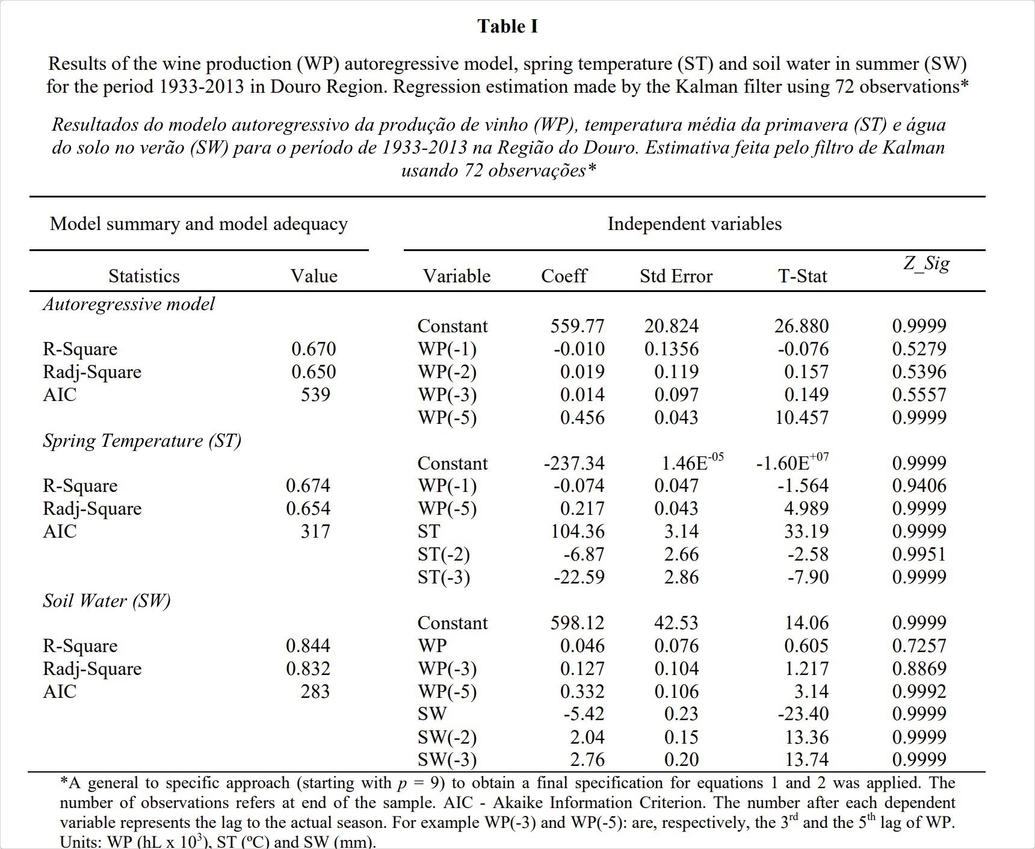 *(Cunha_Richter_CTV.pdf, p.7)*

Excerpt: The time-varying spectrum presented in Figure 3, which is based on the autoregressive model presented on Table I for DR, shows the dynamic characteristics of the WP. Over the entire frequency band, there are three distinctive peaks at frequencies 0.1, 1.1 and 2.5.  *(Cunha_Richter_CTV.pdf, p.7)*

Excerpt: The relationship between period (P, years) and frequency () is P=2*/. For example, a frequency of 0.1 basically represents the long run trend, which can be seen in the upper left hand corner of the Figure 3.  *(Cunha_Richter_CTV.pdf, p.7)*

Excerpt: 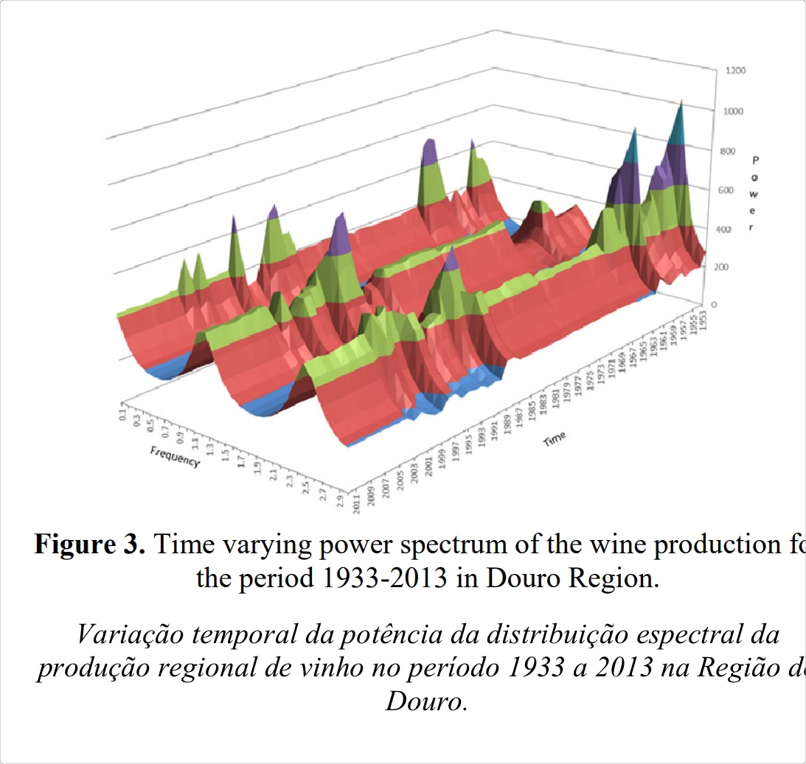 *(Cunha_Richter_CTV.pdf, p.7)*

Object Group

Excerpt: 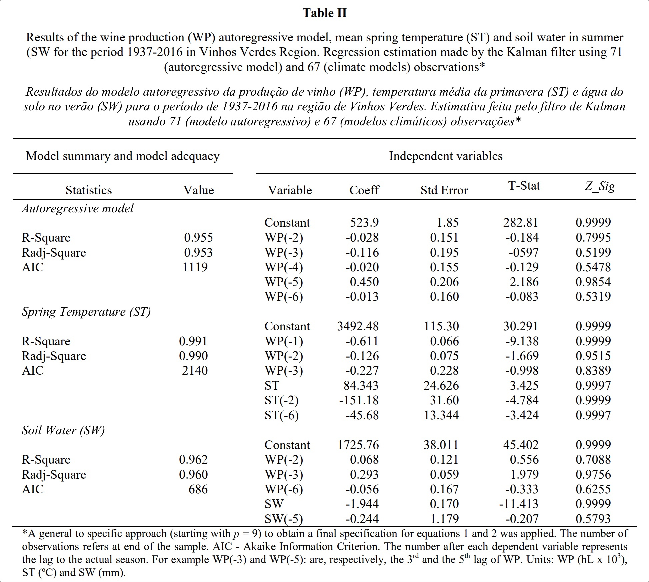 *(Cunha_Richter_CTV.pdf, p.8)*

Excerpt: 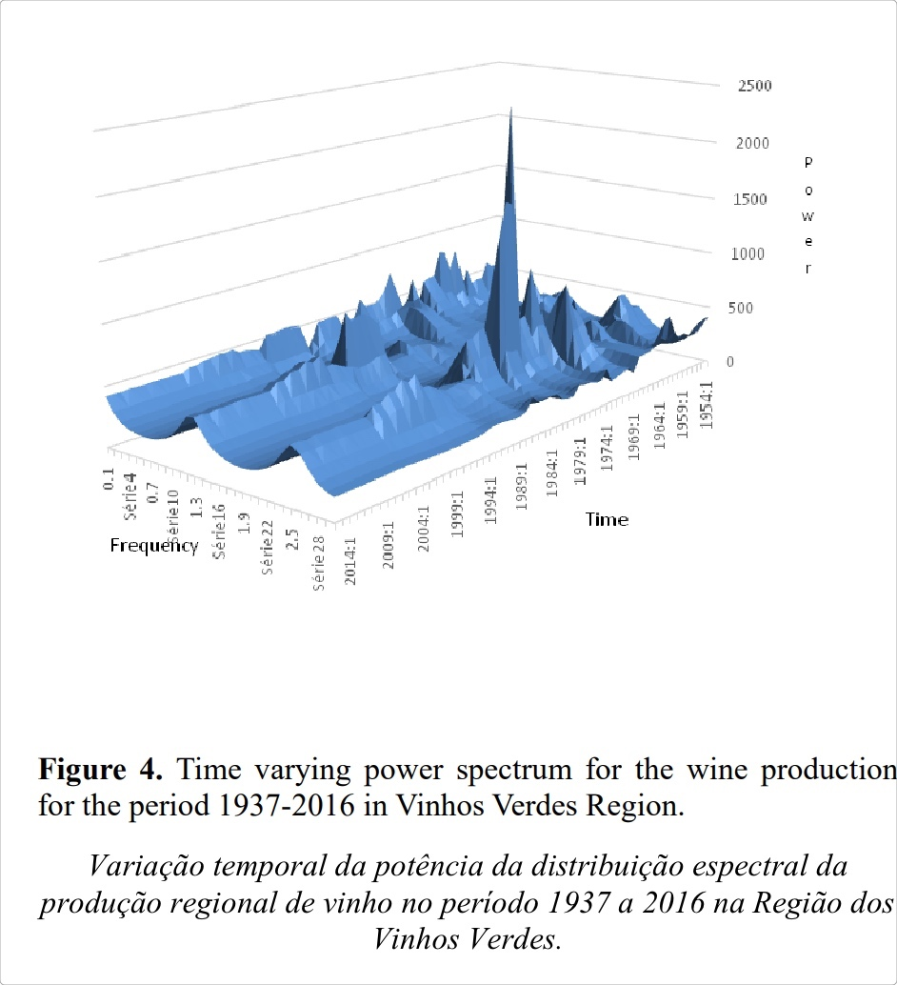 *(Cunha_Richter_CTV.pdf, p.8)*

Excerpt: As can be seen from Figure 4 the VVR power spectrum is towards the end of the sample characterised by three dominant frequencies: the long run trend, the frequency of 1.3 and 2.6, which corresponds to the 4.8 and 2.4 year cycles,  *(Cunha_Richter_CTV.pdf, p.9)*

Object Group

Excerpt: Effect of Spring temperature on wine production   
 *()*

Excerpt: 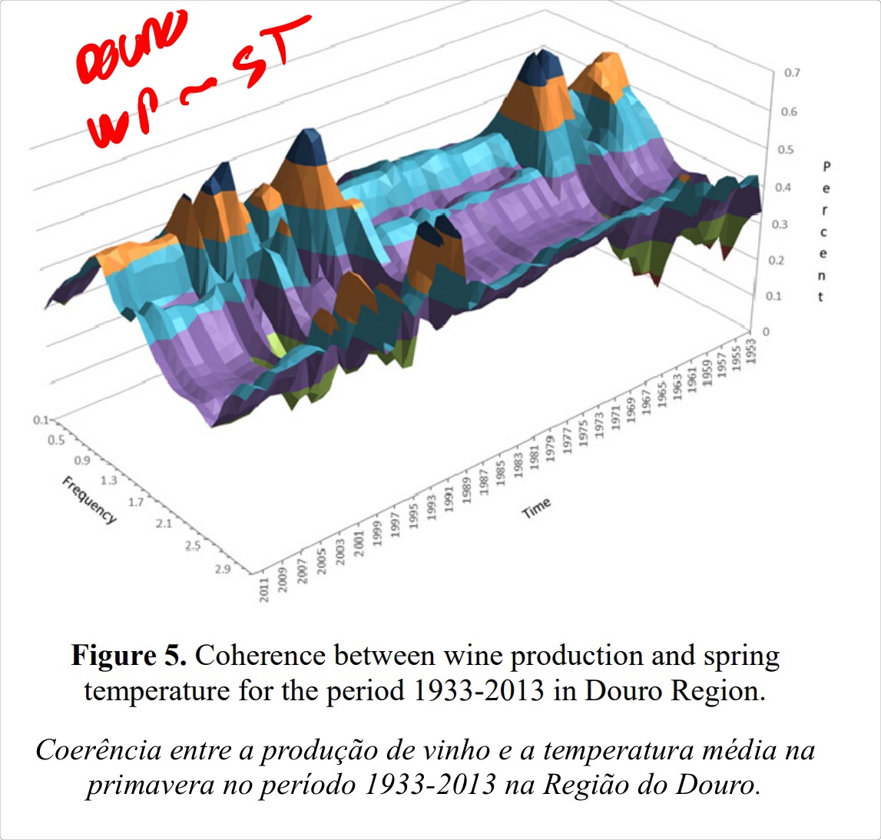 *(Cunha_Richter_CTV.pdf, p.9)*

Excerpt: In comparison to the autoregressive model (Table I), the regression with ST presents similar values for Radj-square (0.65). However, this model with the ST is preferable to the autoregressive one for the lower AIC value (317 in comparison to 539), which of course does not mean that it is the “best” possible model, as the AIC does not reflects the absolute quality of a model. The WP in DR can be modelled using ST *(Cunha_Richter_CTV.pdf, p.9)*

Excerpt: 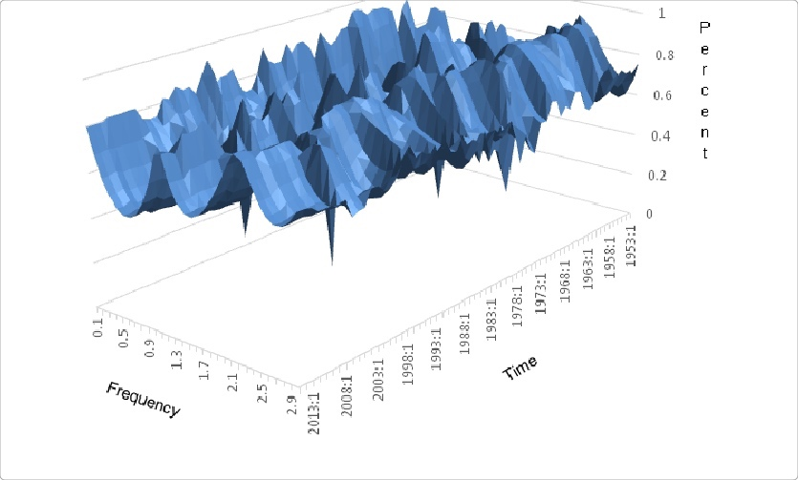 *(Cunha_Richter_CTV.pdf, p.11)*

Excerpt: 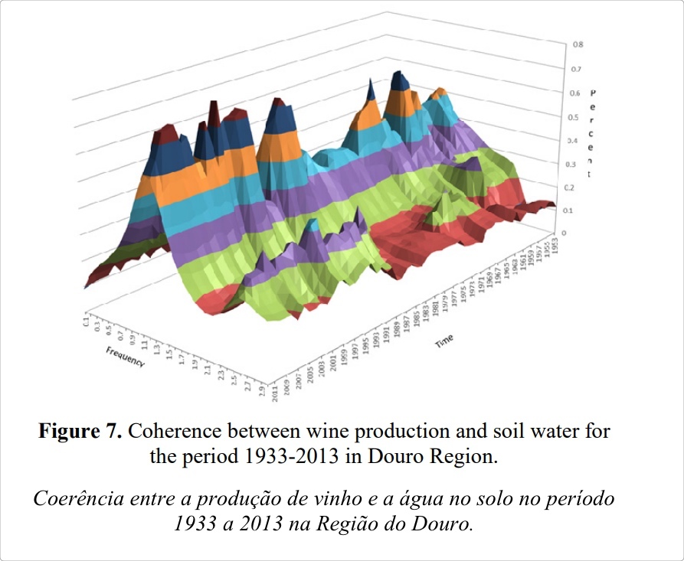 *(Cunha_Richter_CTV.pdf, p.10)*

Excerpt: Effect of soil water in summer on wine production  *(Cunha_Richter_CTV.pdf, p.10)*